

Institution’s Innovation Council, MHRD’s Innovation Cell, AICTE

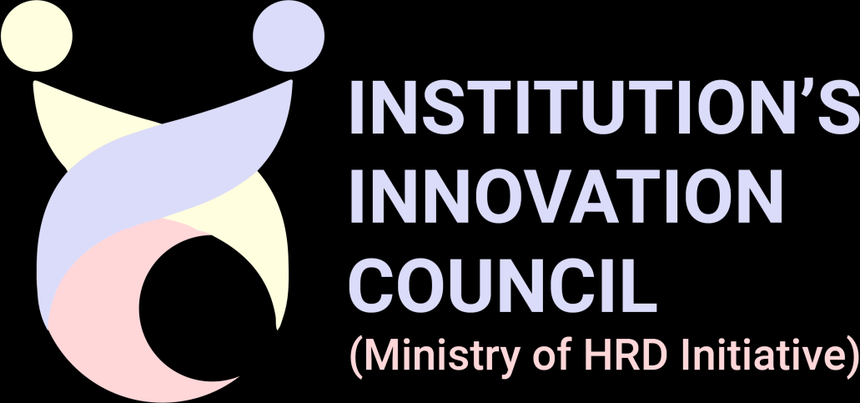
IIC National Innovation Contest 2020 Prototype Evaluation Sheet

Name of the Innovation/Prototype | Eye Controlled Wheelchair using raspberry Pi
Team Lead | Name | Rohit Gupta
Team Lead | Contact No. | 8850377610
Team Lead | Email ID | Gupta,guptarohit9428@gmail.com
Theme | Healthcare & Biomedical devices.

Evaluation Criteria | Maximum Marks (50) | Obtained Marks
A. Innovativeness & Business Potential | 10 Marks
Defined the problem & relevance of solution to today’s market/society/industry clearly | 4 | 4
Described the product/process/ service and uniqueness of innovative clearly | 4 | 4
Defined the potential market size (in terms of INR) and target customers clearly. | 2 | 2

B. Feasibility of solution (SMART) | 20 Marks
(a) Specific- Specified the features of Innovation/ Prototype. | 4 | 4
(b) Measurable- Mentioned the approach to convert prototype in to market ready product with milestones clearly. | 4 | 2
(c) Attainable- Explained clearly about, ‘how the team is going to achieve the commercialization objective with the available  resources at your disposal’ | 4 | 2
(d) Realistic- The skillset of team is in accordance with the requirement of Innovation/Prototype and the requirement of resources is justified. | 4 | 4
(e) Timeline- Developed a robust timeline and mentioned the milestones clearly. | 4 | 2

C. Applicability of Solution | 20 Marks
(a) Usability: The Innovation/ Prototype has potential acceptance among target clientele. | 4 | 4
(b) Scalability: The Innovation/ Prototype is scalable at market level. | 4 | 4
(c) Economic sustainability: The Innovation/ Prototype would be profitable or financially viable at market level. | 4 | 4
(d) Environment Sustainability: The Innovation/ Prototype is environment friendly and or addresses the environmental problems. | 4 | 4
(e) The Innovation/ Prototype has Intellectual Property (IP) Component. (patentable/copyrightable/trademark able etc.) | 4 | 0
*****

